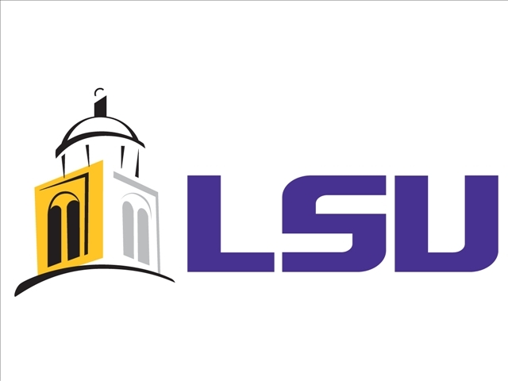
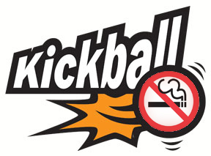

Kick Butts Kickball Proposal
Prepared by Katy Stuart

Event Date: March 16th, Time: TBD
Location: LSU Parade Grounds

Mission: To pre-promote the National Kick Butts Day on March 19th.

About: LSU’s Fresh Campus Organization is proud to announce their first annual Kick Butts Kick Ball Tournament. The main purpose of the kick ball tournament is to raise awareness of Fresh Campus’ mission and goal throughout the LSU community and to promote National Kick Butts day with a fun and exciting event.

Start Date to Promote Event: Monday, February 3rd
- To recruit teams: February 3rd
- To solicit sponsors: February 3rd
- Media: March 3rd

Proposed Budget: $1,500-2,000
- Final costs are TBD. Fresh campus hopes to obtain sponsorships that will help cover some of the costs and make donations.

Breakdown of Promotion Event:
Coordinators: Events, Communications, Logistics

Responsibilities of Events Coordinator:
- Manage the overall event: planning, coordinating, and executing
- Secure date, time, venue with LSU
- Meet with Greek Life, Student Government Association, LSU President’s office and Student Life
- Oversee solicitation of sponsors and in-kind donations
- Secure equipment needed for event: tents, tables, chairs, A/V equipment
- Secure DJ and sound system

Responsibilities of Communications Coordinator:
- Manage and execute all communications for this event
- Coordinate all media: LSU: Daily Reveille, KLSU, Tiger TV, www.lsu.edu
- Coordinate social media: create a Facebook page, twitter, Instagram
- Coordinate local media: The Advocate, BTR Business Report, Guaranty Broadcasting and Clear Channel Broadcasting, TV Morning shows: WAFB: Channel 9, WBRZ: Channel 2
- Coordinate with local Tobacco Free Living Coordinator
- Coordinate with LSU Cheerleaders, Golden Girls, Tiger Girls and Mike for appearances

Responsibilities of Logistics Coordinator:
- Oversee solicitation of teams
- Relay information to teams about the event
- Create an event logistics map
- Coordinate all equipment needed for event
- Coordinate set-up of the event: secure tents, table, chairs
- Meet with LSU Campus police – review event details

Sponsorship: Three levels
- Gold- $200 sponsorship includes logo on the back of the t-shirt (large picture), option to set up tent at the event, and opportunity to promote business during a morning talk show spot
- Silver- $100 sponsorship includes logo on the back of the t-shirt (medium picture), option to set up tent at the event, and radio mentions
- Bronze- $50 sponsorship gets logo on the back of the t-shirt (small picture) and radio mentions
Forms needed:
- Poster artwork to promote the event
- Organizational chart
- Team registration forms
- Sponsorship / in-kind donation forms
- Press releases
- Action item form with dates
- Checklist for each coordinator

Equipment needed:
- 3-4 sets of kick ball bases and 3-4 kick balls
- Tables
- Chairs
- Tents
- DJ equipment
- Signs
- Water and Food
- Ice/Ice Chests
- Trash containers
- Possible A/V: screen/projector/laptop/extension cords

Collateral needed:
- Trophy for tournament winner
- Prize for first place team (i.e. gift card to local restaurant)
- Buttons, stickers, fliers and info sheets
- T-shirts (different colors for each team participating)

