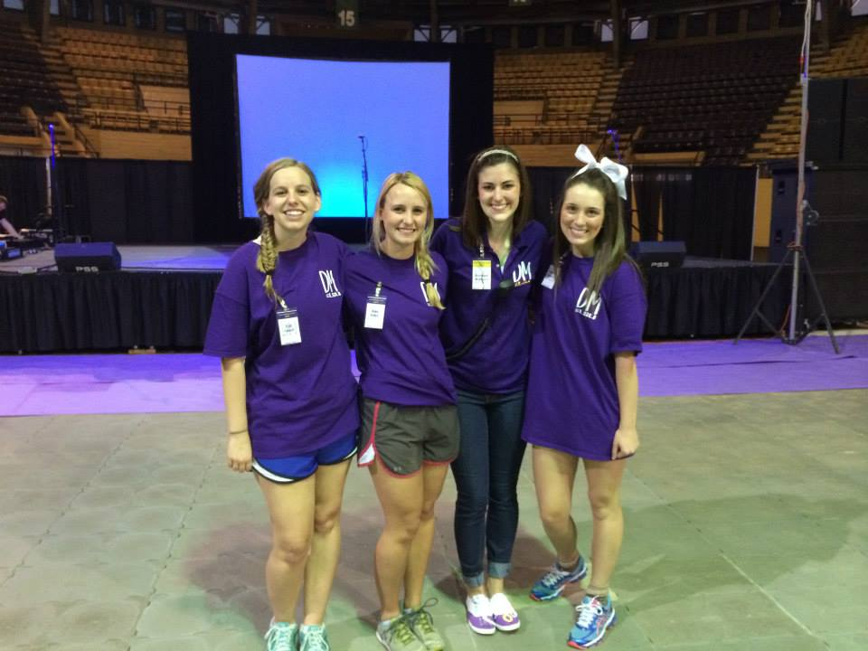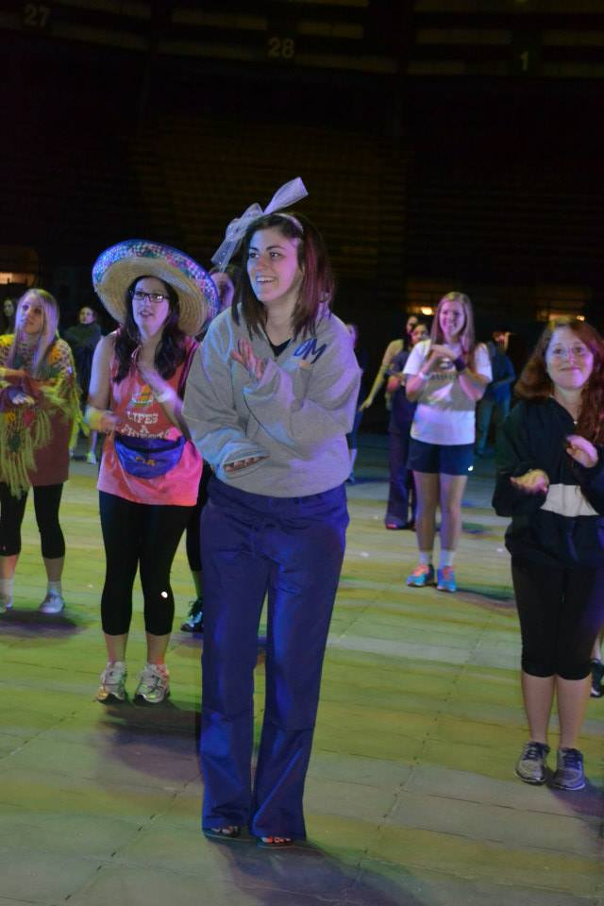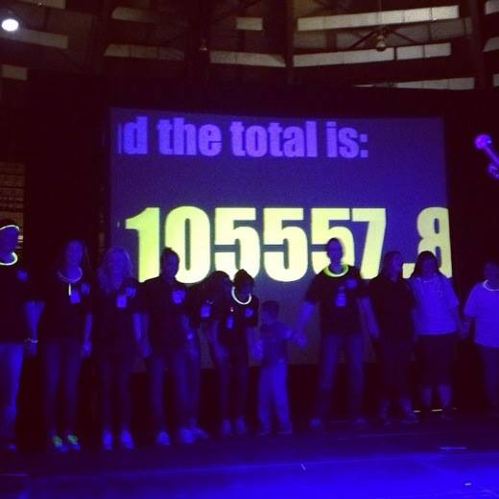

for any student who is looking to give back to the community and have fun.”

This positive attitude and genuine passion for others and Dance Marathon itself is what has landed Welborn the position of 2014 Executive Director of Dance Marathon. Over the past year Welborn believes that the biggest thing she has learned is that two minds are always better than one. She knows that Dance Marathon would not have been possible without the immense

campus, and not long after the first info meeting the Board of Directors and Assistant Directors were chosen. Working off of existing Dance Marathons across the country, LSU’s Dance Marathon worked from the ground up and started building an organization and fundraising efforts that fit will with the students of LSU and the Baton Rouge community.

Many great organizations benefit deserving causes. One of the special aspects about LSU having a Dance

Founders thought this needed to be changed.

For Rachael Welborn, junior and Slidell native, the spirit of Dance Marathon was easily relatable and she knew from the beginning that it was something that she wanted to be a part of. Last February, after the initial meeting between the four students and advisor, an informational meeting was held where members like Welborn first became involved with Dance Marathon. From there Dance Marathon spread like wildfire across

In 2013 Louisiana State University embarked on a journey to begin the Dance Marathon organization here on campus. Dance Marathon is a nationwide fundraising movement that supports Children’s Miracle Network Hospitals. The idea for LSU to hop on the Dance Marathon bandwagon was sparked by a group of four students and one advisor who believed in the good that Dance Marathon accomplishes. LSU is one of the last SEC schools to have a Dance Marathon organization on campus, and LSU’s Dance Marathon

Marathon was February 21st and February 22nd. During the 26.2 hour event participants stayed on their feet, played games and danced the night away in honor of those who can’t.

“For me joining Dance Marathon was about helping the kids at Our Lady of the Lake Children’s Hospital as well as uniting our campus and community,” Welborn said. “Dance Marathon at LSU is a unique organization in that you don’t have to fit a stereotype to join. Dance Marathon at LSU is

Marathon is that participants can directly see how and where the money raised goes to help families and children in need. Baton Rouge is home to Our Lady of the Lake Children’s Hospital, which is a Children’s Miracle Network Hospital. Patients and their families who have been treated and cared for by Our Lady of the Lake were in attendance for LSU’s first Dance Marathon event.

LSU’s inaugural Dance

### The Story of How 26.2 Hours Can Change a Life

### By: Katy Stuart

# And We Danced All Night to the Best Song Ever

April 2, 2014



in LSU’s quad with a flash mob of the 2013 morale dance. For The Kids, FTK, is a chant one would have hear being shouted loud and proud by Dance Marathon members during the flash mob. This chant is one Dance Marathon participants hope will leave a mark on all who hear it and stand as a reminder to give back to those in need.

teamwork distributed by committee members, directors, moral captains and dancers.

“I want to see next years Dance Marathon at LSU to be bigger and better,” Welborn said. “We hope to get more students, faculty and community partners involved so we can raise more money For The Kids!”

2013 Dance Marathon participants released the date for the 2014 Dance Marathon